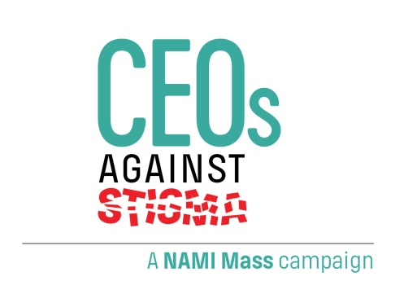

What it means to become a
CEO Against Stigma

1. Personal Leadership - Educate yourself and other top
executives in understanding mental illness and best practices
in the workplace. Start by sending a memo to all employees
stressing the importance of stamping out stigma.
I will act as an Ambassador for CEOs Against Stigma by seeking to enlist fellow CEOs whom I believe share my commitment to a stigma- free workplace.
2. In Our Own Voice - Bring NAMI's “In Our Own Voice" (lOOV)
presentations into the workplace to further understanding and
empathy about mental illness. IOOV has been documented as
one of the most effective anti-stigma programs in America.*
3. Stigma-Free Workplace - Work with NAMI to promote
productivity by encouraging open dialogue among employees
about mental illness. Start by distributing and posting NAMI
Mass. materials for employees and managers.
4. Helpful Health Benefits - Examine employee health and
welfare benefits to ensure availability of effective benefits for
mental illness and addiction.
5. EAP - Strongly consider an Employee Assistance Program
(EAP), and if you have one, make sure it is welcoming to all
with mental health issues and effective in providing assistance
to them.
6. Public Awareness - Participate with NAMI Mass., through
linked websites and media awareness, in educating the public
about how to move beyond stigma.

*Patrick W. Corrigan, Jenessa R. Shapiro, "Measuring the impact of programs that challenge the public stigma
of mental illness" Clinical Psychology Review 30 (2010) 907-922; Patrick W. Corrigan et al. "Changing
stigmatizing perceptions and recollections about mental illness: the effects of NAMl's “In Our Own Voice"
Community Mental Health Journal, 46(2010), 517-522.

09/15

The National Alliance on Mental Illness of Massachusetts
The Schrafft's Center • 529 Main Street · Suite 1M17 • Boston, MA 02129-1125 P: 617.580.8541 F: 617.580.8673 Toll free: 800.370.9085
E-mail: info@namimass.org W: www.namimass.org

